**Assignment 10.6**

1.Write a pig script to find the minimum temperature observed in a given weather station in a particular year.

2. Write a pig script to find the maximum temperature observed in a given weather station in a particular year.

3. Write a pig script to find the number of readings given by each weather station according to the dataset.

You can download the dataset from the below link Temperature_Data

Data Definition: Column 1: Weather Station Column 2: Date(year/Month/Day) Column 3: Observation Type Column 4: Temperature

1.Write a pig script to find the minimum temperature observed in a given weather station in a particular year.

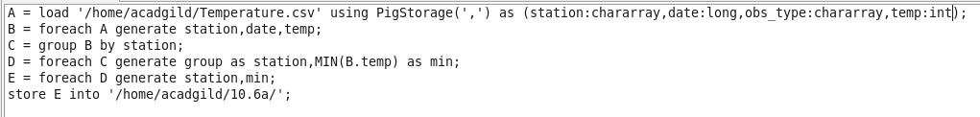

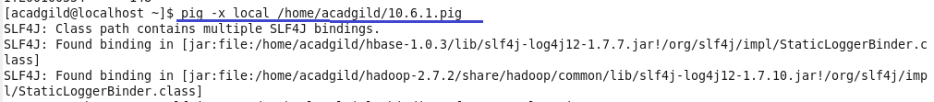

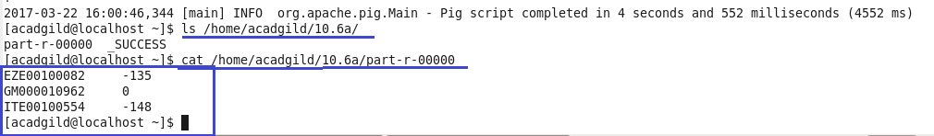

2. Write a pig script to find the maximum temperature observed in a given weather station in a particular year.

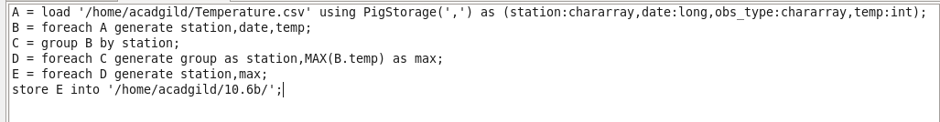

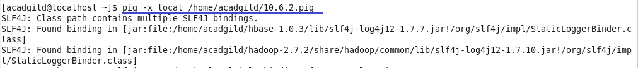

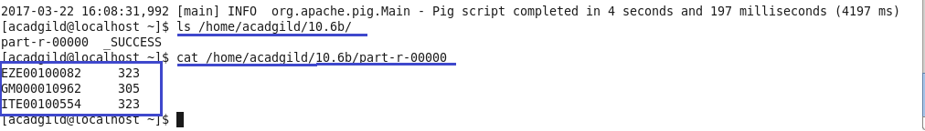

3. Write a pig script to find the number of readings given by each weather station according to the dataset.

